My TITANIC TALE,
(since you wanted to hear it...sit down, it takes a while to get going!)
I had a few minutes and since a few of you have asked to hear the story sometime...I figured that I better write to it down so I don’t forget something as I would if I told it in person...and I’ll then have this written down to pass on to others who may want to hear it in the future. I had mentioned that for a long time, I have had this overwhelming feeling that in a past life I was once a passenger on the Titanic, on her maiden voyage in April 1912 when she struck an iceberg and sank in the North Atlantic.
I remember being interested in the Titanic way back when I was a kid...read a lot of books..saw all the old, really bad movies...was just very interested. Now this was way back before the Titanic was ever even found again, and all the subsequent interest in her ensued. But as I went through life, a series of things happened along the way to really convince me and make me feel that somehow I was connected to this story a lot more closely than I ever expected.
Each of these pieces to this strange puzzle are in themselves singularly pretty meaningless and unremarkable...but when you put them all together, at least to me, it really gets a little creepy!
#1 My strong interest in this terrible tragedy ever since I was a young boy.
#2 .....My Grandparents Paul & Christine Zubriski lived at 924 Lackawanna Ave in Elmira...at that time it was right across from the old Delaware, Lackawanna & Western Railroad yards (now the Clemens Center Parkway). My Grand Dad used to work for that Railroad. When my cousins and I used to be over there visiting back in the “60’s...we always used to go exploring up at the old railroad platform that used to be next to the same bridge that still crosses over Washington Avenue near Lackawanna Ave. Near the far side of the platform..back behind where Albee Truck Co. was just formerly located...was the Lackawanna Railroad passenger station. This building was a big structure, made out of this yellow terra cotta stone.....it was built around 1910 and was used until the late ‘50’s early 1960’s when passenger service was discontinued to Elmira the place was boarded up. Being boarded up, we always tried getting inside, and I just remember being fascinated with this building...the ornate ornamentation, the large dome shaped windows, the lettering spelling out LACKAWANNA on the front and back side of it...something about that place just captured my imagination. In the summer of 1969 Albee’s bought the building and had it demolished, and I remember walking over there one afternoon with my Grandfather when I was 12 to watch the wrecking ball knock the grand old place to dust. I’m sure my Grandfather was very sad seeing this once grand old building fall to dust. As we were watching, a round part of the terra cotta stone ornamentation....a post to one of the decorative railings up on the roof came rolling over towards us and I grabbed it, and to this day I still have it.
Why did I keep this chunk of that long ago forgotten building for so long? Why such intense interest in this old place? I didn’t know then...but eventually I think I found the answer.
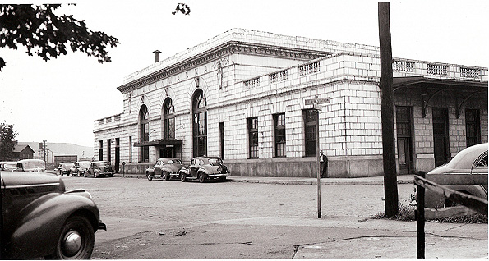
#3...... In July 1986, ...It is now almost a year since Titanic’s wreckage was finally found in September 1985 by Dr. Robert Ballard, my girlfriend (now wife) and I took off for a weekend and went to visit a couple of friends who lived in New Jersey, and together we were going into Manhattan to be a part of the rededication of the Statue of Liberty after its refurbishing. On our way into the city we drove to Hoboken where we parked the car in a municipal lot near the Metro Station where we were going to catch the train under the Hudson and into the World Trade Center Station. As we walked toward the Hoboken Metro Station, I realized that in the past it was the Hoboken Passenger Station for the Delaware, Lackawanna & Western Railroad. Once again, I was really intrigued by this huge old building which had been renovated and brought back to its magnificent past glory. You see, in real cities they bring these great old temples back to life by restoring them ..... they don’t just tear them down as they did in Elmira years earlier. It is this beautiful Copper Green color....again with a lot of ornamentation as was popular at the time...and once again, just as I had been in Elmira, I just felt overwhelmed and drawn to it for some reason. I had this familiar feeling upon seeing it, and walking through it, even though I had never been there in my life. At least not in... this life.
#4......In August 1993.....Being an old railroad history buff , I was on vacation and decide to take a drive down just outside of Scranton, PA to the little village of Nicholson, PA to see something that all railroad historians have heard about, and that is the Tunkhannock Viaduct. This is a tremendous bridge structure over 1200 feet long, and over 300 feet tall, and when built in 1912 it was the largest concrete structure anywhere in the world.
Take a guess what Railroad this bridge was built to carry over it and across this beautiful Pennsylvania Valley? You got it...the Delaware, Lackawanna & Western Railroad.
Anyway I spent a couple of hours exploring the bridge, underneath it, and I also climbed up to it and crossed over it, from one end to the other, and took a lot of photographs, and collected a few pieces of concrete and copper flashing that I found still attached to it.
I don’t know exactly when it was that I found out the following bits of information and finally put all the pieces of information together to solve this puzzle....but sometime after my visit to the Bridge...while doing some more Titanic reading and research...I learned that there actually was a local connection, a man who was on his way back home.....to Elmira, NY from London and a European Vacation, as a Second Class Passenger on that fatefull maiden voyage. A passenger who grew up in Millport, NY, and who attended and Graduated from Horseheads High School (as I did). He went to and graduated from our local Cornell University.
More info about his life I’ll copy right here.....
Mr William Hull Botsford was born in Binghamton 1 on 23 November 1886 the son of cabinetmaker 2 William B. Botsford.
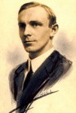
(Courtesy of Talitha Botsford, John Pulos, USA)
Botsford grew up in Millport NY. A picture from 1897 shows young William Hull standing on the porch of his childhood home.
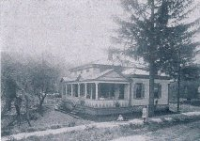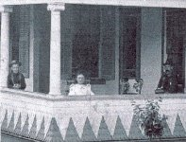
(Courtesy of Talitha Botsford, John Pulos, USA)
As a boy he was educated at Horseheads High School one of only two boys in a class of eight 3.
After leaving school at the age of sixteen Botsford worked for two years in the architectural office of Pierce and Bickford in Elmira 4 as well as a firm based in Rochester, NY.
After his work experience Botsford went to study at Cornell University College of Architecture. He demonstated great drawing ability, indeed one of his works was hung in the library there. His skills also led to a commission for the cover of The Cornellian, the University yearbook in 1910. While at college William developed an interest in wrestling. A lightweight, he gained national and state honours in YMCA tournaments after leaving college. He was also a keen singer.
After graduating Botsford become chief designer for the Delaware, Lackawanna and Western Railroad. He designed many stations in the New York and New Jersey area including those at Elmira, Bath, New Village, Hopatcong, Basking Ridge, Watessing, Bloomfield, Syracuse, Utica, Hoboken and Ithaca. The last station Botsford would design was at Montclair. After his death a memorial stone and window was erected there.
During his time with the DL&W Botsford lived in Orange, New Jersey. He taught night classes sponsored by the YMCA and occasionally contributed to architectural magazines.

Botsford's last and most substantial work was the Tunkhannock Viaduct (aka Nicholson Bridge) near Nicholson, PA. Half a mile long and 100 feet higher than the Brooklyn Bridge the viaduct was designed to carry the Lackawanna railroad. The design was only accepted by the railroad board just as Botsford was leaving for home. His ship was the Titanic.
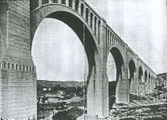
Tunkhannock Viaduct
(Courtesy of John Pulos, USA)
William had taken leave to travel in Egypt, and Turkey and throughout Europe to study architectural design and techniques. For the return journey he boarded the Titanic at Southampton as a second class passenger. He held ticket number 237670, price: £13.
According to his sister Talitha 6 who was 10 years old at the time:
We were eating supper when the neighbor across the street came over and asked if we had seen the Star-Gazette. That was the first we knew of it.
We watched the papers and as soon as they printed the list of the missing, we knew.
Mr Botsford died in the sinking. His body, if recovered, never was identified 5. He is, however, remembered on a family grave at Millport Cemetery, New York.
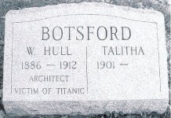
(Courtesy of John Pulos, USA)
A memorial service was held at the Orange, NJ YMCA. A. G. Hallock a friend from Cornell made the following address:
He left a record of modesty and unselfishness which led his friends at the very first to give up hope that he might have been rescued. He would have thought first of the women and children and then of those having greater responsibilities than he.
Edit this biography.
Notes
1. Eva Taylor (Undated) William Hull Botsford - Ill Fated Genius. Chemung Historical Journal. pp. 1728-1730
2. Unidentified Newspaper (1980s) Titanic: Elmiran remembers her brother who died on ill-fated cruise ship.
Note: At one time Botsford senior took leave from his employer and during his sabbatical crafted six violins one of which his daughter Talitha played throughout her tenure at Ithaca College Conservatory of Music. Four of the violins were given to Cornell University and another to J. Emory Botsford (later of Brandon, Florida), Talitha and William's brother.
3. Eva Taylor op. cit.
Note: The other boy was Chester Moore who would later become the manager of the Elmira Bank & Trust Co.
4. Eva Taylor op. cit.
Pierce and Bickford were responsible for many public buildings in Elmira including the Steele Memorial Library and the City Hall. They were pioneers in the use of reinforced concrete which Botsford would later use in his greatest construction works.
5. One list suggests that body #194 was that of William Botsford, the reasoning is unclear. The body, which was buried at sea, was tentatively identified as a fireman.
6. Talitha Botsford, who grew up to become a poet, was still living, aged 99 in April 2000.
References and Sources
Passport Application (January 1912)
Newark Evening News, 17 April 1912, W. Hull Botsford, of Orange, may be Lost
Contract Ticket List, White Star Line 1912 (National Archives, New York; NRAN-21-SDNYCIVCAS-55[279])
Marriages, births, deaths and injuries that have occurred on board during the voyage (PRO London, BT 100/259-260)
United States Senate (62nd Congress), Subcommittee Hearings of the Committee on Commerce, Titanic Disaster, Washington 1912
Credits
Talitha Botsford, USA
Sidney Boardman
Phillip Gowan, USA John Pulos, USA
Hermann Söldner, Germany

After finding all of this information out...that he designed all of these railroad structures that have held my fascination since early in my childhood.....I just knew that I was him in a past life....that we are the same person.....that is the only thing that I can come up with to explain these feelings if interest in and the familiarity with all of these structures, and also in the story of Titanic’s fatal maiden voyage.
In the late 1990’s...1997 I think....I met with Hull’s Sister, Talitha at her home on West Water Street in Elmira. Hull is what she called him.
An older friend of my family...Rudy Baer, knew her personally and agreed to take me over to her place and introduce us so we could visit for a while. Rudy was in his early 90’s, and Talitha was about 97...and quite an invalid in a wheelchair...but her mind was still pretty sharp. She was only 10 when Hull died, but told me a little bit about him, and she also let me hold and feel some of his drafting tools, his Compass and T-Squares, Rulers & Dividers. I held a couple of his books,
I can’t say that I got any eerie feelings or anything...but it was just really neat to touch something that He touched almost 100 years earlier. And also to meet and talk to his/my Sister. I never told her about all of this, about what I through our connection was.....she probably would have clobbered me with a crutch or something!!!

So that’s my story...what do you think? Am I nuts, or what?

